**Fall 2022 DSI Capstone Project**

**Progress Report 2**

**Optimized EV Charging Locations**

**in Washington State**

Nov 22, 2022

**Student Team Members**

**Anqi Lin** al4215

**Clarissa Tai** rt2822

**Mengchen Xu** mx2257

**Yue Zhang** yz4155

**Yu-Chieh Chen** yc4015

**Industry Mentors**

**Alexander Voet**, Data Scientist, Associate at KPMG Lighthouse

**Arvind Sathi**, Director at KPMG Lighthouse

**Chengwei Wang**, D&A Data Scientist, Associate at KPMG Lighthouse

**Jeffrey Lee**, Lighthouse D&A Modeler, Associate at KPMG

**John Heath**, Director at KPMG

**Michelle Zee**, D&A Consultant, Sr. Associate at KPMG Lighthouse

**Sydney (Bolim) Son**, D&A Data Modeler, Associate at KPMG Lighthouse

## 

## 

**1. Background** **2**

**2. EV Station Count Prediction Model** **2**

2.1 Data Wrangling 2

2.2 Feature Selection 3

2.3 Model Development & Evaluation 3

2.4 Prediction Results 4

**3. EV Station Location Optimization Model** **5**

3.1 Model Formulation 5

3.1.1 Variables 6

3.1.2 Objective Function 6

3.1.3 Constraints 6

3.2 Model Result 7

3.3 Alternative Model 8

3.3.2 Comparison Result 10

**4. Proposed Location Scoring Model** **10**

4.1 Intuitive Base Model 10

4.3 Logistic Regression 10

4.4 Random Forest Classification 11

4.5 XGBoost Classification 12

4.6 Model Comparison 12

**5. Appendix - Contributions** **13**

**6. Appendix - Data Source and Features** **14**

## 

## **1.** Background

In this project, we will tackle the challenge of how to best electrify our roads and communities to encourage balanced growth in our communities. We defined our research question as follows: what are the most important factors to consider when choosing EV charger locations in Washington state and where are potential optimal locations. To solve the problem, we will integrate machine learning methods together with optimization models to predict and optimize the number of charging stations and chargers along major routes in WA.

In our 1st progress report, we reasoned why we chose WA as our focus, and performed exploratory data analysis, concluding that factors affecting the decision to place EV charging stations include natural risk index, crime rate, nearby tourist attractions and traffic coverage. To solve the question of where and how many new EV charging stations should be placed, we firstly use ML model, which learns from the existing pattern, to decide how many EV charging stations may be in each area, and use the optimization model to select and optimize our result. After getting the optimized result, we can create scores on newly selected locations to indicate whether the location is a good choice for building new EV charging stations.

## 

## 2. EV Station Count Prediction Model

To tackle the problem of how many EV charging stations to put in each area, we experimented with a machine learning model to predict the number of EV stations in each census tract area by assuming that those in fully-developed areas/cities are optimal. We trained models on census tracts with non-zero number of EV stations or is labeled as cities. The model is then used to predict the number of EV stations in those without EV stations, mostly rural. The predictions will be treated as the reference number for optimization and hope to leverage further discussion. Here, we try on several regression models and select XGBoost as our final model.

### 2.1 Data Wrangling

For classification models, predictions were by each gas station. However, for this problem, we need to reform the data we have. To prepare the applicable dataset, entries were aggregated by census tract index. New features such as average of daily traffic, maximum daily traffic, count of attractions in the area were created.



Figure 2.1 Generalization specific data process.

### 2.2 Feature Selection

Initially, all features are included in the dataset. However, as shown in Fig. 2.2, many crime-related features are highly correlated. We hence decided to only include the total crime population and also filtered other highly-correlated features. It is worth mentioning that even if some features are generated from the same data source, such as maximum daily traffic counts and average daily traffic counts, they performed low correlation, inferring that they retained different information.

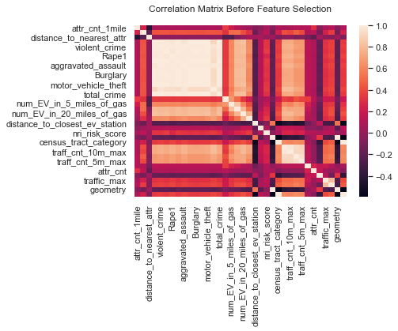

Figure 2.2 Correlation matrix before Feature selection[1]

### 2.3 Model Development & Evaluation

We compare 4 regression models, two linear models, and two tree-based models, which are Linear regression, Gamma Regressor, Random Forest Regressor, and XGBoost Regressor. The Gamma Regressor was chosen because the distribution passed the Kolmogorov-Smirnov test, indicating that it follows the gamma distribution. The hyperparameters are selected through randomized grid search and 5-fold cross-validated. The results are shown in Table 2.1. Based on the results, XGBoost Regressor was selected as the final model and proceeded to predict EV station counts in each census tract.

| **Regressor** | **Linear** | **Gamma** | **Random Forest** | **XGBoost** |
| --- | --- | --- | --- | --- |
| **Best hyperparameters** | N/A | max_iter: 200,  alpha: 0 | n_estimators: 500, max_depth: 3 | subsample: 0.6,  min_child_weight: 1,  max_depth: 5,  learning_rate: 0.01,  gamma: 1.5,  colsample_bytree: 1.0 |
| **training MSE** | 9.56 | 11.07 | 5.84 | 1.15 |
| **validation MSE** | 6.49 | 8.72 | 3.31 | 0.94 |
| **training r-square** | 0.05 | -0.10 | 0.42 | 0.89 |
| **validation r-square** | 0.20 | -0.07 | 0.59 | 0.88 |

Table 2.1 Model Evaluation Results.

### 2.4 Prediction Results

The feature importance is shown in Fig. 2.3. Number of attractions in the specific census tract area is the most important feature, followed by the average number of daily traffic counts within a 5 mile radius.

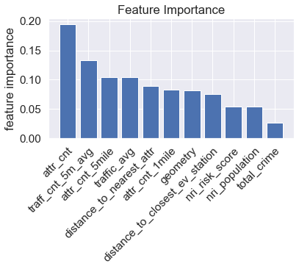

Figure 2.3 Feature importance of the selected model.

Previously, we observed that most EV charging stations are in the cities, where the census tract area is smaller geographically and densely populated, or along highways leading to national parks and famous attractions. The imbalance between traffic demand and supply of the critical interstate highway draws our attention. For example, the current distribution of EV charging stations along the southern section of I-5 highway is shown in the left first plot of Fig. 2.4, and the prediction results are shown on its right side for better comparison. Advanced discussions about the findings will be proceeded in Section 3: Optimization. In this section, we will briefly show the overall patterns of the model predictions on Washington state and along southern I-5 highway. The final prediction is shown in the right first plot of Fig. 2.4. The figure also included the predicted results of the training subset to leverage insights. The empty census tracts in the figures are those lacking gas stations, as we were not able to generate the features for these areas.

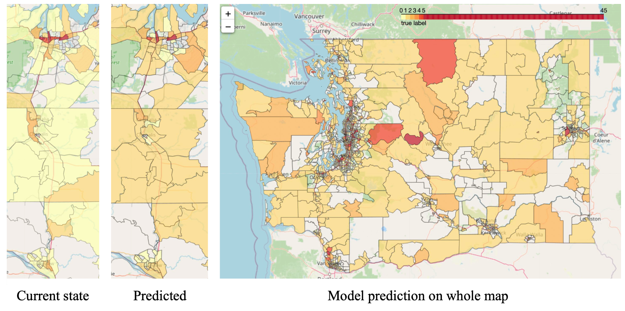

Figure 2.4 Model Prediction, included the predictions on training data.

## 3. EV Station Location Optimization Model

After knowing the predicted number of new EV charging stations in each census tract area, we need to decide exactly where to put new EV charging stations in an optimal way minimizing the station and charger number. We decided that our constraints on this problem will be:

1. The driving distance from highway exits to each locations should be less than 10 miles (to make sure the newly suggested EV stations are near the highways)
2. Newly added EV stations can support all EV traffic demand
3. Charger count at each location should not exceed 15[2] (to make sure the charger count is reasonable at each location)

### 3.1 Model Formulation

Due to the limitation of our traffic count data which only includes all types of vehicles along highways, to calculate the EV traffic demand, we decided to multiply the total traffic count by the ratio of registered EV among all vehicles which is 1.6%[3].

To calculate the supported EV traffic by each charger, we made the assumption that, in busy Seattle city areas, the EV stations supply is already sufficient for covering all EV traffic, so we can calculate a ratio of supported EV traffic per charger based on the data present in Seattle city areas. The ratio is calculated as follows: for each exit on I-5 in the Seattle city area, we calculate the maximum annual average daily traffic count within 2 miles and the number of EV stations within 2 miles. Then the ratio of supported traffic per charger is traffic count within 2 miles divided by the number of EV stations within 2 miles. Then we take the average of each ratio on exits and come to the final ratio. To approximate the EV traffic, we multiply the ratio by 1.6%. The final estimated supported EV traffic per charger is 168.

#### **3.1.1 Variables**

1. $x_{i}$, denoting the number of new chargers to place in each candidate gas station location.
2. $d_{i}$, denoting the driving distance from highway exits to each candidate gas station.
3. $y_{i}$, denoting the existing EV charger count within 5 miles on each candidate location.
4. $e_{i}$, denoting the maximum EV traffic count within 5 miles on each candidate location.

#### **3.1.2 Objective Function**

We can express our total number of chargers in the area as $\sum{}x_{i}$ and we want to minimize it.

#### **3.1.3 Constraints**

To satisfy the constraints we mentioned previously, we firstly need to make the driving distance from highway exits to each locations less than 10 miles , which means $d_{i}<10.$

According to the demand of EV traffics, our total existing number of chargers and newly proposed number of chargers should cover all the EV traffics going through the area, which gives the expression ${(x}_{i}+y_{i} + x_{j∈\{other proposed charger cnt within 5 miles of i\}})×ratio ≥e_{i} .$

Also, the number of chargers should be an integer no more than 15 and not negative.

Combining all the results above, we formulate the mathematical model as:

$minimize \sum{}x_{i},$

$subject to d_{i}< 10$

${(x}_{i}+y_{i} + x_{j∈\{other proposed charger cnt within 5 miles of i\}})×ratio ≥e_{i}$

$x_{i}∈Z, x_{i}≤15, x_{i} ≥0$

### 3.2 Model Result

To start from a smaller area and generalize it to the whole map, we initially focused our model on the I-5 south area, which is a typical area with comparatively more traffic and less EV charging stations.

Based on the consideration proposed by KPMG that, if we create more EV stations along the route, there will be an increased EV traffic percentage. Therefore, we ran our model on three scenarios based on different EV% of all traffic: EV account for 1.6% of total traffic (current state), EV account for 3.0% of total traffic (projected % in 2026) and EV account for 5.0% of total traffic (projected % in 2030).

Using the Mixed-Integer Linear Program Solver on Gurobi, we get the result in Figure 3.1.

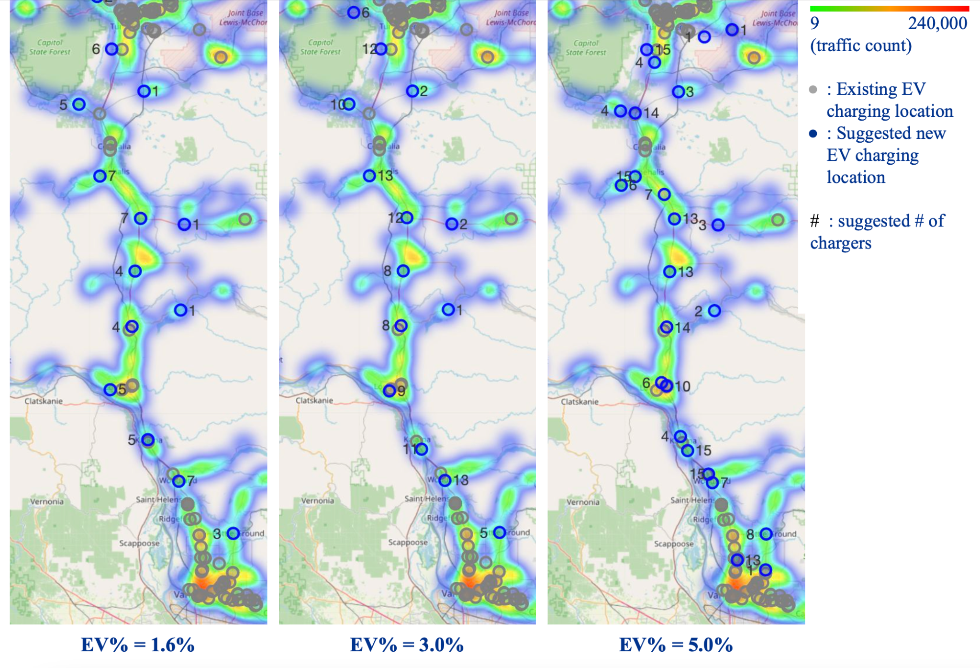

Figure 3.1 Optimization model result on different EV% scenarios

Model-suggested new EV charging station locations are evenly scattered around comparatively rural areas along areas where higher traffic is presented. In addition, in areas with existing EV charging locations, our model doesn’t suggest a lot of newly built EV charging stations, which are performing as we expected. In addition, as the EV traffic percentage increases, the proposed number of chargers increases, and more locations appear near the city area.

Applying the current model on the entire I-5, I-90, and I-84 route on different EV% scenarios, the result is shown in Figure 3.2.

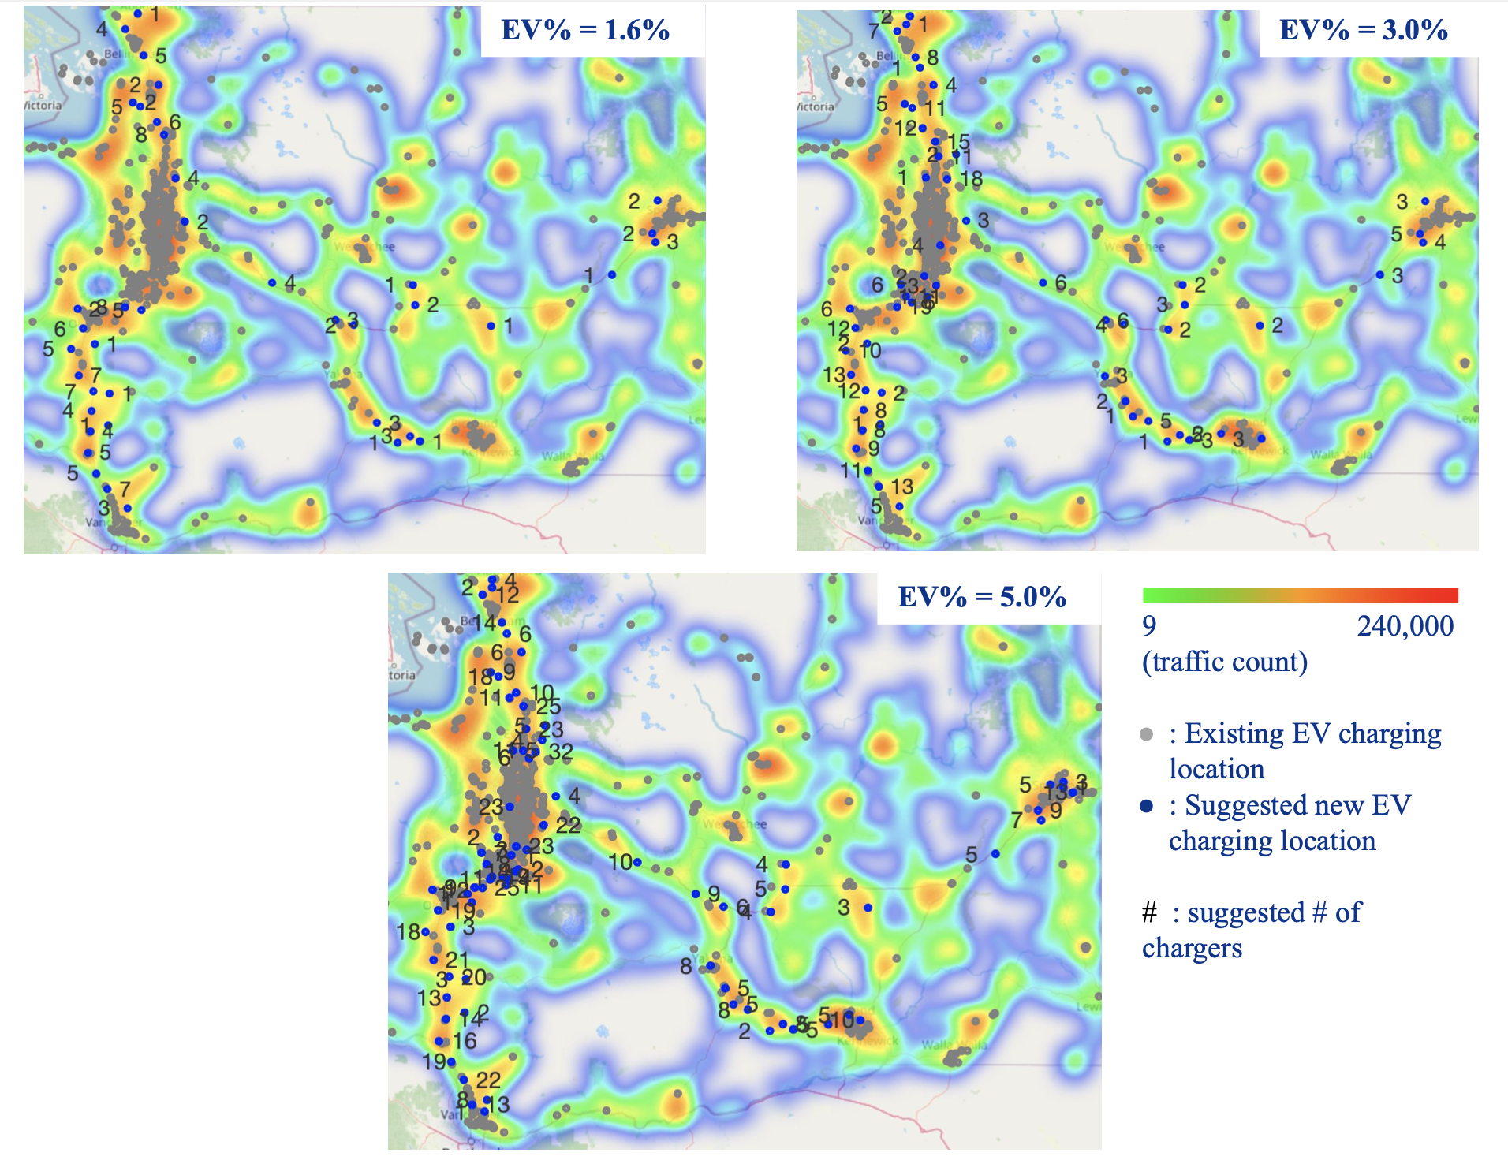

Figure 3.2. Model result on I-5, I-90 and I-82

### 3.3 Alternative Model

After building our model with an objective function of minimizing the number of chargers, which minimizes the cost of building new EV charging stations and chargers, we considered another way to optimize based on different objective functions that may lead to different locations with constraints remaining the same. Our alternative objective function is to minimize total distance to nearest exists from all stations $\sum{}d_{i}$. The reason to select this objective function is that there are extra costs for each EV car driving from exits to the gas station location, which can be an extra penalty on the cost for more far-away stations.

On the I-5 south area, based on three scenarios with different EV% of all traffic: EV account for 1.6% of total traffic (current state), EV account for 3.0% of total traffic (projected % in 2026) and EV account for 5.0% of total traffic (projected % in 2030), our alternative model result is shown in Figure 3.3.

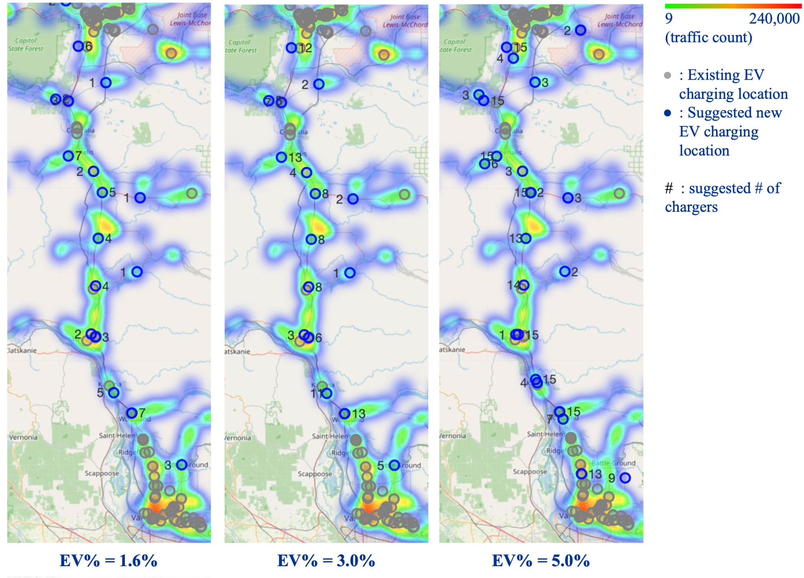

Figure 3.3 Alternative model result on different EV% scenarios

Compared to the original model, our alternative model minimizing total distance to nearest exits from all stations gives similar optimized locations with some small differences.

**3.3.1 Evaluation Metric**

Considering that there are extra costs on each car driving from exits to the gas station location, we decided that our evaluation metric will be the total cost of building stations, adding chargers, and the penalty of the cost of each EV car driving from exits to the stations.

After researching online, we estimate the rough cost for building an EV charging station in WA as $30,000, the cost for adding an EV charger in a station in WA as $8,000[4], and the cost for an EV per charger driving a mile as $0.15[5]. Therefore, the total cost will be calculated as $30000×\sum{}1_{\{if x_{i}>0\}}+8000×\sum{}x_{i}+0.15×ratio×e_{i}×d_{i}$.

#### **3.3.2 Comparison Result**

After deciding the evaluation metrics, we calculated our cost on both models. The result is as follows:

| EV% of all traffic scenarios | Model | Total suggested locations | Cost | Difference |
| --- | --- | --- | --- | --- |
| EV% = 1.6% | Original: minimizing charger count | 13 | $785,086 | ~$90,000 |
| Alternative: minimizing distance | 16 | $874,278 |
| EV% = 3.0% | Original: minimizing charger count | 13 | $1,288,670 | ~$60,000 |
| Alternative: minimizing distance | 16 | $1,348,591 |
| EV% = 5.0% | Original: minimizing charger count | 23 | $2,063,685 | ~29,000 |
| Alternative: minimizing distance | 24 | $2,092,414 |

Although the cost on alternative models is always higher than the cost on the original model, this is caused by the fact that the original model produces less charging stations, which accounts for a larger portion of the total cost. When the EV traffic count increases, the penalty of the cost of each EV car driving from exits to stations plays a bigger role, causing the cost difference to decrease. Therefore, by adjusting the cost coefficients, there will be a point where our alternative model outperforms our original model. However, under the current situation, we can conclude that the model minimizing the charger count works better regarding the cost.

## 4. Proposed Location Scoring Model

In order to give insights on the different importance levels of each optimized EV station location, we decided to propose a score for all the optimized EV station locations. The higher the score, the more we want to recommend that EV station location.

#### **4.1 Intuitive Base Model**

We only used 3 features in this model, number of attractions, total crime, and natural risk score. Give each feature the same weight (weight = 1), and scale the range of each column of the data (one column is one feature) from 0 to 1 by applying Min-Max Scaler. Sum up all the numbers to get a final score for each EV station. Finally apply Min-Max Scaler on the score again to make them range from 0 to 1 and multiply by 100. The final score ranges from 0 to 100.

#### **4.2 Logistic Regression**

Fit a Logistic Regression Model and predict the probability of labeling each proposed EV station location as optimized EV station locations. Recording the predicted probability as the recommendation score of that proposed EV station location.

After we’ve dropped all highly correlated features (>0.85) in the Logistic Regression Model, the model result is shown in Figure 4.X. The model shows a large false positive rate, which will cause the probability score to be a bit higher since the model tends to predict positive results. The feature with the highest importance is aggregate assault.



#### **4.3 Random Forest Classification**

Fit a Random Forest Classification Model with GridSearch Cross Validation and predict the probability of labeling each proposed EV station location as optimized EV station location. Find out the feature importance of all features in the Random Forest Classification model.

The overall probability of predicting the proposed EV locations as optimized locations are not high overall in the Random Forest model. However, the relative probabilities among all the proposed locations have some overlap with the result obtained from the logistic regression model. The random forest model sounds more reasonable compared to logistic regression model since the top 5 important features are reasonable to have high influences on choosing optimized EV charging locations.



#### **4.4 XGBoost Classification**

Fit a XGBoost Classification Model with GridSearch Cross Validation and predict the probability of labeling each proposed EV station location as optimized EV station location. Find out the feature importance of all features in the XGBoost Classification model.

The overall probability of predicting the proposed EV locations as optimized locations are very small in the XGBoost model. It suggests the lowest score among all the models, and it suggests the lowest amount of optimized EV station locations. The top five important features are very similar to the Random Forest model.



#### **4.5 Model Comparison**

The predicted scores of different models are shown in Figure 4.4.



Based on the results, the scores obtained from the intuitive based model are almost the opposite compared to other models. The locations that have high recommendation scores predicted by the intuitive base model are having low recommendation scores in Logistic Regression and Random Forest models. The relative scores between EV station locations in both Logistic Regression and Random Forest have similar trends. Thus, we will consider the scores obtained from Logistic Regression and Random Forest models to be more accurate. The scores obtained from XGBoost are not reasonable since it predicts a very low score for multiple locations which is not helpful for us to make the decision for the business recommendation.

| **Model** | **Features**  **Used In Model [6]** | **Best Estimators** | **Precision** | **Recall** | **F1 Score** | **Accuracy** |
| --- | --- | --- | --- | --- | --- | --- |
| 1. Intuitive Base Model | N4 N17 N18 | N/A | N/A | N/A | N/A | N/A |
| 2. Logistic Regression | N4 N5 N6 N9 N11 N15 N18 B1 B2 | N/A | 0.51 | 0.97 | 0.67 | 0.65 |
| 3. Random Forest | N4 N5 N6 N7 N8 N9 N10 N11  N12 N14 N15 N18 B1 B2 | 'max_depth'= 150, 'max_features'= 'log2', 'n_estimators'= 200 | 0.81 | 0.78 | 0.80 | 0.85 |
| 4. XGBoost | N4 N5 N6 N7 N8 N9 N10 N11  N12 N14 N15 N18 B1 B2 | 'learning_rate'= 0.1, 'max_depth'= 50, 'n_estimators'=50 | 0.77 | 0.77 | 0.77 | 0.83 |

## **5. Appendix - Contributions**

* Anqi Lin: Team captain. Main contributor for creating and improving the optimization model, and forming the business case question: how to score each optimized EV station.
* Clarissa Tai: Main contributor for creating and improving EV Station Count Prediction Model; researching supplementary documents and datasets to support optimization model assumptions.
* Mengchen Xu: Improving the optimization model, and forming the business case question. Main contributor for scoring model and comparison.
* Yue Zhang: Contributor for creating and improving the optimization model, and forming the business case question: how to score each optimized EV station.
* Yu-Chieh Chen: Researching supplementary documents and datasets to support optimization model assumptions.

## **6. Appendix - Data Source and** Features

6.1 Data Sources

* Washington State Plan for Electric Vehicle Infrastructure Deployment, July 2022 <https://wsdot.wa.gov/construction-planning/statewide-plans/washington-state-plan-electric-vehicle-infrastructure-deployment>
* U.S. Energy Information Administration. “Electricity.” <https://www.eia.gov/electricity/>. Accessed 5 October 2022.
* Energy Efficiency & Renewable Energy. “Alternative Fuel Data Center.” <https://afdc.energy.gov/fuels/electricity_locations.html#/analyze?fuel=ELEC>. Accessed 5 October 2022.
* National Risk Index <https://hazards.fema.gov/nri/data-resources>. Accessed 5 October 2022.
* Annual Average Traffic Count <https://gisdata-wsdot.opendata.arcgis.com/datasets/WSDOT::wsdot-traffic-counts-aadt-1/explore?location=47.271387%2C-119.745108%2C6.90> Accessed 11 October 2022.
* Crime <https://ucr.fbi.gov/crime-in-the-u.s/2019/crime-in-the-u.s.-2019/tables/table-8/table-8-state-cuts/washington.xls> Accessed 5 October 2022.
* MAPQUEST <https://developer.mapquest.com/documentation> Accessed 15 October 2022.
* Washington Geospatial Open Data Portal <https://geo.wa.gov/datasets/WSDOT::wsdot-interstate-exit-numbers-1/api> Accessed 12 October 2022.
* Tourist Attraction <https://mygeodata.cloud/data/download/osm/tourist-attractions/united-states-of-america--washington> Accessed 5 October 2022.

6.2 Data Features

| **Column Name** | **ID** | **Data Type** | **Description** |
| --- | --- | --- | --- |
| gas_key | N1 | Numerical | Gas station key |
| gas_lat | N2 | Numerical | Gas station location latitude |
| gas_long | N3 | Numerical | Gas station location longitude |
| attr_cnt_1mile | N4 | Numerical | Number of tourism attractions within 1 mile distance |
| attr_cnt_5mile | N5 | Numerical | Number of tourism attractions within 5 mile distance |
| distance_to_nearest_attr | N6 | Numerical | Distance to the nearest tourists attraction |
| violent_crime | N7 | Numerical | Number of violent crime cases |
| murder_nonnegligent_manslaughter | N8 | Numerical | Number of muder/non-negligent manslaughter cases |
| Rape1 | N9 | Numerical | Number of rape cases |
| Robbery | N10 | Numerical | Number of robbery cases |
| aggravated_assault | N11 | Numerical | Number of aggravated assault cases |
| property_crime | N12 | Numerical | Number of property crime cases |
| Burglary | N13 | Numerical | Number of burglary cases |
| larceny_theft | N14 | Numerical | Number of larceny-theft cases |
| motor_vehicle_theft | N15 | Numerical | Number of vehicles stolen cases |
| Arson | N16 | Numerical | Number of arson offenses |
| highway | C1 | Categorical | Name of highway, for example “I5” |
| total_crime | N17 | Numerical | Number of summed crimes (including theft, burglary, murder, etc.) |
| nri_risk_score | N18 | Numerical | Relative risk of natural hazards at a location, higher value means higher risk, a number in range [0,100] |
| matched | B1 | Boolean | True if an EV station is located within 1 mile of the gas station; false otherwise |
| census_tract_city | B2 | Boolean | True if the gas station location is in city; false otherwise |

1. Labels are plotted every other feature due to spacing.
2. U.S. average EV charger per station reference: <https://www.iea.org/reports/global-ev-outlook-2022/trends-in-charging-infrastructure>
3. Reference: <https://afdc.energy.gov/transatlas/#/?state=WA&view=per_capita&fuel=GA>
4. Charger cost reference: <https://afdc.energy.gov/files/u/publication/evse_cost_report_2015.pdf>
5. Driving cost reference: <https://ecocostsavings.com/electric-car-cost-per-mile/>
6. The feature names refers to the Data Features Form in Appendix